**Instructions to run**

As I am already hosting the site on Omega, to merely access the site, all that is required is to visit <http://omega.cs.iit.edu/~nmoutrey/home.php> for the user site, or <http://omega.cs.iit.edu/~nmoutrey/admin.php> for the admin control panel. Detailed instructions for downloading the site data and hosting it locally are given below.

**Instructions to host**

Step 1) Visit <https://github.com/nmoutrey/CS487>

This is the public repository for the site. It has the latest version of the code for the site, as well as other files such as diagrams and test cases. You need not be logged in to download any files. Click the Downloads button towards the right (picture below), and choose to download the source code as either a zip or a tar.gz file, and unzip it into a folder on your machine.

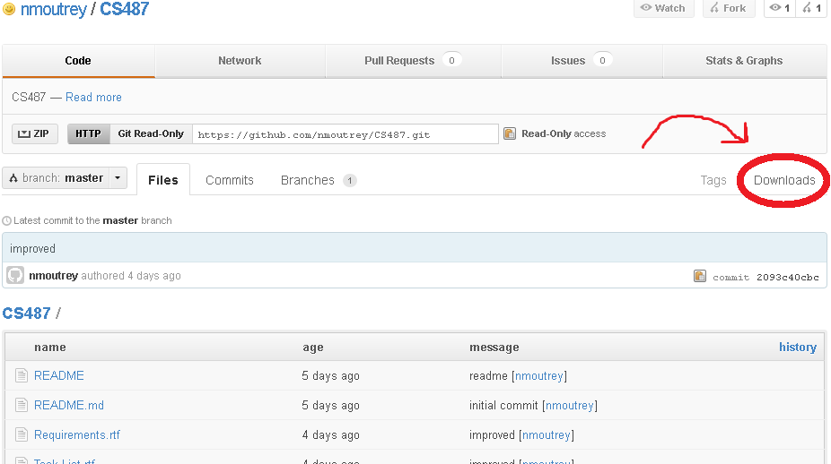

However, having the source code does not allow you to preview the file locally. You must have a server set up on which to place the webpage files. The rest of these instructions will assume that you have an Apache web server set up on a linux machine. Apache is free, so if you do not already have it, acquiring it is trivial. Note, however, that the repository does not include an index.html file.

Once you have an Apache web server set up, you can place all of the .php files in the default directory for serving files, which will usually be */var/www*. (This may differ on other servers though, if they are set up differently. For example, on Omega, the default directory is */public_html*. If you are not the owner of the server, check with them to find out the proper directory for the files, as well as whether or not the following steps are necessary.).

2) Configure Apache

Now that the files are present, Apache must be configured in order for it to recognize the newly placed site. The configuration file needed is in the /*sites-available* directory – here there is a skeleton file named default which will be helpful. Copy this file, and name the copy after the website. Afterwards, the name of the website must be edited into certain parts of the file. The picture below shows which changes have to be made, highlighted in red, with the website name ‘Website A’, which will differ from your site name.

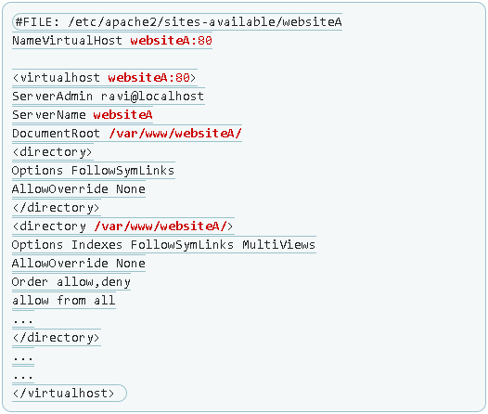

Picture from <http://www.aboutlinux.info/2006/02/host-websites-on-your-local-machine.html>

3) Edit Hosts file

Outside of the */apache2* directory, there is a *hosts* file, which should say something like this:

“127.0.0.1 localhost.localdomain localhost”

Add in a space to the end of the line, and then the website name, and save the file.

4) Restart Apache

Just before restarting, move back into the */apache2* directory and go back to */sites-enabled*. Run the following command:

**ln -s /etc/apache2/sites-available/websitename**

Replacing ‘websitename’ with the name you chose in Step 2. Afterwards, to restart Apache, run this command:

**apache2ctl restart**

Now, you should be able to see the website by going to <http://websitename>, replacing websitename with the name you chose in Step 2.